NOTE: all references to "database" refer to the AP database that goes with the book. You may use the ap database or your ap_*userid* database.

**Q1-Q6 – 5 points each = 30 points**

1. Run a SELECT statement to return all the General Ledger Accounts records whose account number is 500-549.

*Paste your SQL statement and results here.

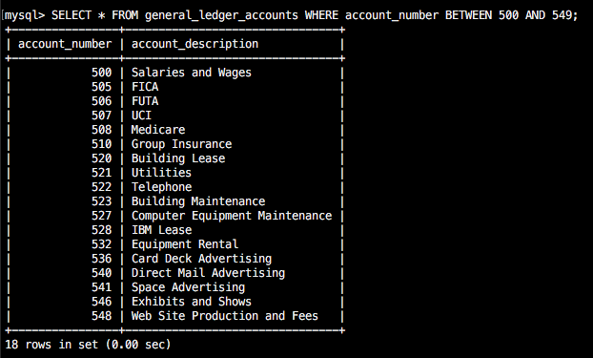

2. Run a SELECT statement to return a list of the Vendor Contacts. Please return only one field which shows *last name, first name* (don’t forget the comma).

*Paste your SQL statement and results here.

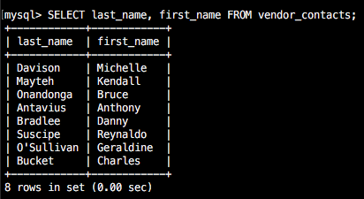

3. Run a SELECT statement that shows the invoice_number, vendor_id, invoice_date, and invoice_balance (invoice total minus payment total) for only vendor_id 121 from the invoices table.

*Paste your SQL statement and results here.

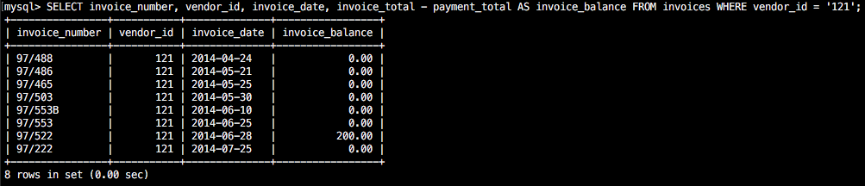

4. Run a SELECT statement that **alphabetically** lists all vendor names, address1, city, and state from the vendors tables, for all vendors in New York.

*Paste your SQL statement and results here.

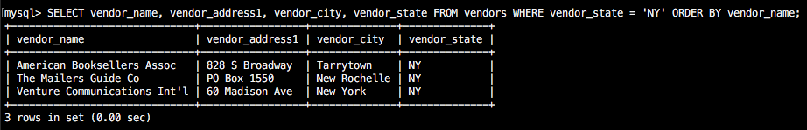

5. Run a SELECT statement to list all vendors from California (alphabetically) whose default_account_number is 540, along with their phone numbers.

*Paste your SQL statement and results here

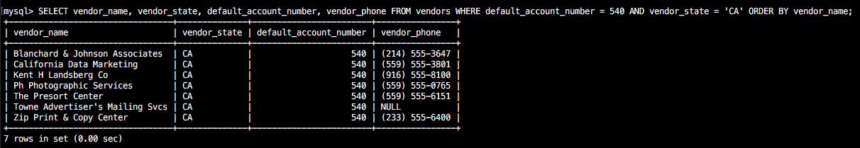

6. Run a SELECT statement to list all invoice lines from invoice 12 which were charged to account 570.

*Paste your SQL statement and results here

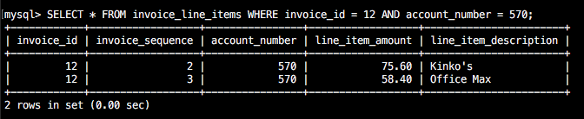

**Q7-Q9 – 9 points each = 27 points**

7-9. Make up and run 3 SELECT statements of your own to find specific things. You may use any database and any table, just be sure to list them.

*Paste your SQL statement and results here.

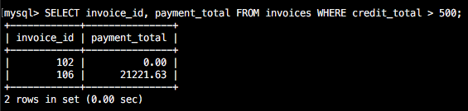

Screen Shot 2017-06-26 at 11.40.36 PM.png

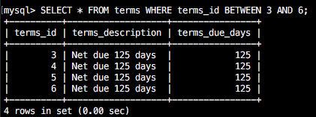

Regular Expressions: Jeopardy Time

You have been given a new database called misc. In it you will find several tables that will/can be used for the remainder of this assignment.

You will be given code and results (answer), you are then to provide the question which is being answered. You may use any table(s) you want for the section you write.

EXAMPLE:

**A.** SELECT first_name, last_name FROM member WHERE last_name rlike '^b.*o{2}';

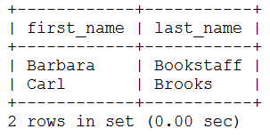

**Q.** Select first name and last name of all members have a last name beginning with b and contains two o’s

**Q10-Q16 – 4 points each = 28 points**

**A10. SELECT first_name, email FROM member WHERE email rlike '^[a-z]_';**

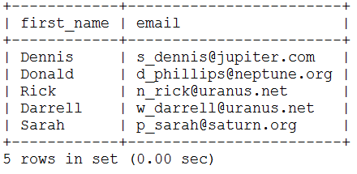

**Q10:**

**Select first name and email of all members who’s email begins with any letter followed by an underscore**

**A11. SELECT first_name, email FROM member WHERE email rlike '^[c]\\..*net$';**

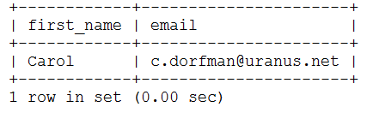

**Q11:**

**Select first name and email of all members who’s email that begins with c, has anything after that, and ends with net**

**A12. SELECT first_name, last_name FROM member WHERE last_name rlike 'land$';**

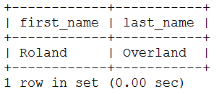

**Q12:**

**Select first name and last name of all members who’s last name ends with land**

**A13. SELECT first_name, last_name, interests FROM member WHERE interests rlike 'immigration';**

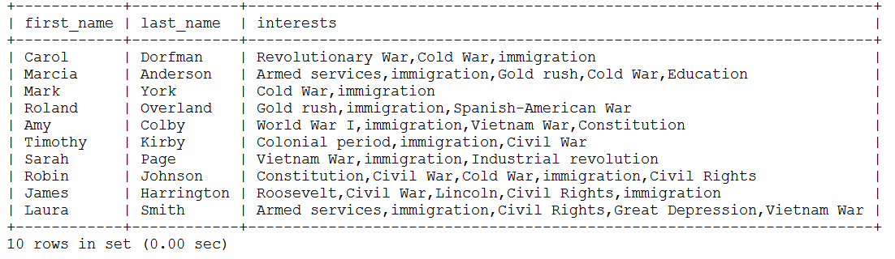

**Q13:**

**Select first name, last name, and interest of all members with interests including immigration**

**A14: SELECT concat_ws(' ',first_name, last_name ) AS ‘Full Name’**

**FROM member WHERE last_name rlike 'o.*o' order by last_name, first_name;**

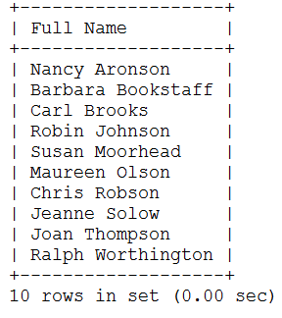

**Q14:**

**Select a concatenation of first name and last name as Full Name of all members who’s last name has two o’s somewhere in the last name**

**A15: SELECT CONCAT_WS(' ',first_name, last_name ) AS Member FROM member**

**where last_name rlike 'son' order by last_name, first_name;**

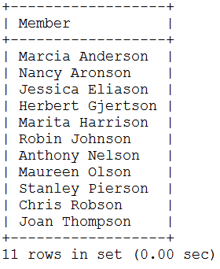

**Q15:**

**Select a concatenation of first name and last name as Member of all members who’s last name includes “son” and order by last name then first name**

**A16: SELECT CONCAT_WS(' ',first_name, last_name ) AS Member, street FROM member**

**WHERE street rlike binary 'W.*W' order by last_name, first_name;**

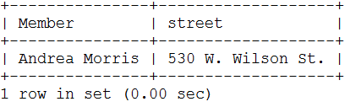

**Q16:**

**Select a concatenation of first name and last name as Member of all members who’s street starts with a capital W, matches anything in between, and has another capital W.**

**Q17-Q19 – 5 points each = 15 points**

**Your turn – provide 17, 18, 19**

**Select all the vendors who’s name starts with t**

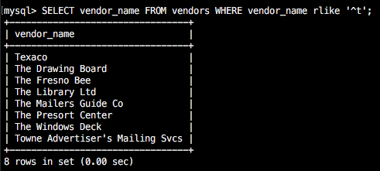

**Select all the vendors who’s name matches the patterns “son”, “pat”, or “wen”**

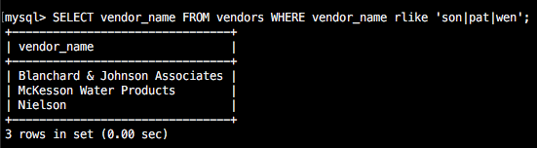

**Select all the vendors who’s name begins with s, matches anything in between, and ends with s**

